LEARNER WORKBOOK
FULL NAME & SURNAME

ID NUMBER:

NAME OF ASSESSOR

DATE OF ASSESSMENT

VENUE

COURTNEY ROSENBERG
2ND FLOOR, 679 PAUL KRUGER STREET LES MARAIS, 0084

MODEL ANSWERS
ACHIEVED |  | NOT ACHIEVED
KNOWLEDGE
SKILLS

Signature of learner Signature of Assessor
In terms of the Copyright Act 1978:

No part of this manual may be reproduced or translated in any form or by any means, electronic or mechanical including photocopying, recording or by an information storage and retrieval system without the express permission from TDA.

COPYRIGHT: TRAINING DYNAMICS AFRICA
First edition 2007

Publications disclaimer

Neither the authors nor the SETA can accept any responsibility for any legal or any other consequences, which may arise directly or indirectly as a result of the use or adaptation of or reliance upon any of the content of this material.

This material has been compiled based on the UNIT STANDARD 244176 USE SECURITY EQUIPMENT.

The program has been accredited by SASSETA in the Republic of South Africa.

Material compiled by: Training Dynamics Africa

HOW THIS LEARNER WORKBOOK IS COMPILED

This learner workbook has been compiled to guide you through the use of security equipment in various situations. Learners will be able to understand when and how certain equipment may be used and under which conditions.

- Explain the safekeeping and storing of security equipment

- Demonstrate the use of security equipment

- Confirm the working condition of security equipment

You have to study the content and guidelines given in your learner reference guide to complete this workbook.

Remember that this completed workbook must be handed in as it will form part of your formative assessment and will play a role in awarding you the required credits that are to be achieved upon completion of this module.

Write neatly and legibly and ensure that you do not simply copy the information contained in the learner reference guide into your workbook. Give your own opinion and ideas where applicable and write the answers in your own words to indicate your level of understanding and learning.

Good luck with the completion of this workbook.

LEARNING UNIT 1

Batons
♦ Describe 2 types of batons.
♦ Demonstrate the common grips for 2 kinds of batons.
♦ Discuss safety guidelines for batons.
♦ Demonstrate defensive maneuver skills when using a baton/tonfa ♦ Demonstrate skills in baton retention.
♦ Explain the legal guidelines for the use of batons.
♦ Demonstrate the correct carry method when carrying a baton.

LEARNER ACTIVITY 1 (page 16 & 17)

Identify each type of baton by completing the attached diagram.

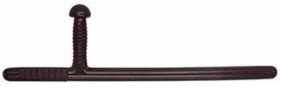

Tonfa
[1]
4

5

2

3

1

Type of baton
- Front head
- Handle
- Blade
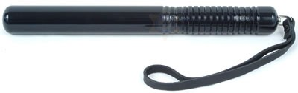
[5]

Back head
[1]

Straight baton
1

Type of baton
3

2

4

- Blade
- Grip
- Wrist strap

_______________________________________________________________________
_______________________________________________________________________
Requirements achieved | YES |  | NO
Comments in support of decision
_______________________________________________________________________
_______________________________________________________________________
_______________________________________________________________________
_______________________________________________________________________
LEARNER ACTIVITY 2

Demonstrate the grip on each of the type of batons.
Straight baton |  | Yes | No | Comments
Did the learner:
1. | Put the wrist strap around his wrist.
2. | Grip the baton on the hand grip
3. | Grip the baton firmly
4. | Play with or mis-use the baton |  | X

Requirements met
Tonfa |  | Yes | No | Comments
Did the learner:
1. | Grip the baton on the hand grip
2. | Grip the baton firmly
3. | Play with or mis-use the baton |  | X
Requirements met

Comments in support of decision
_______________________________________________________________________
_______________________________________________________________________
_______________________________________________________________________
_______________________________________________________________________
_______________________________________________________________________
LEARNER ACTIVITY 3

Demonstrate defensive maneuvers with the tonfa.
Raising block: |  | Yes | No | Comments
Did the learner: |  |  |  | 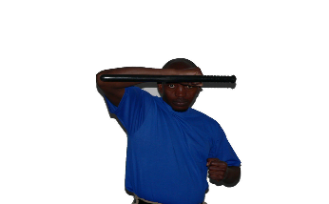
1. | Raise the baton well above his head on a 45 degree angle. |  |  | Take pics of the learner
Lower section block:
1. | Swiftly sweep his arm down across and past his body line. |  |  | 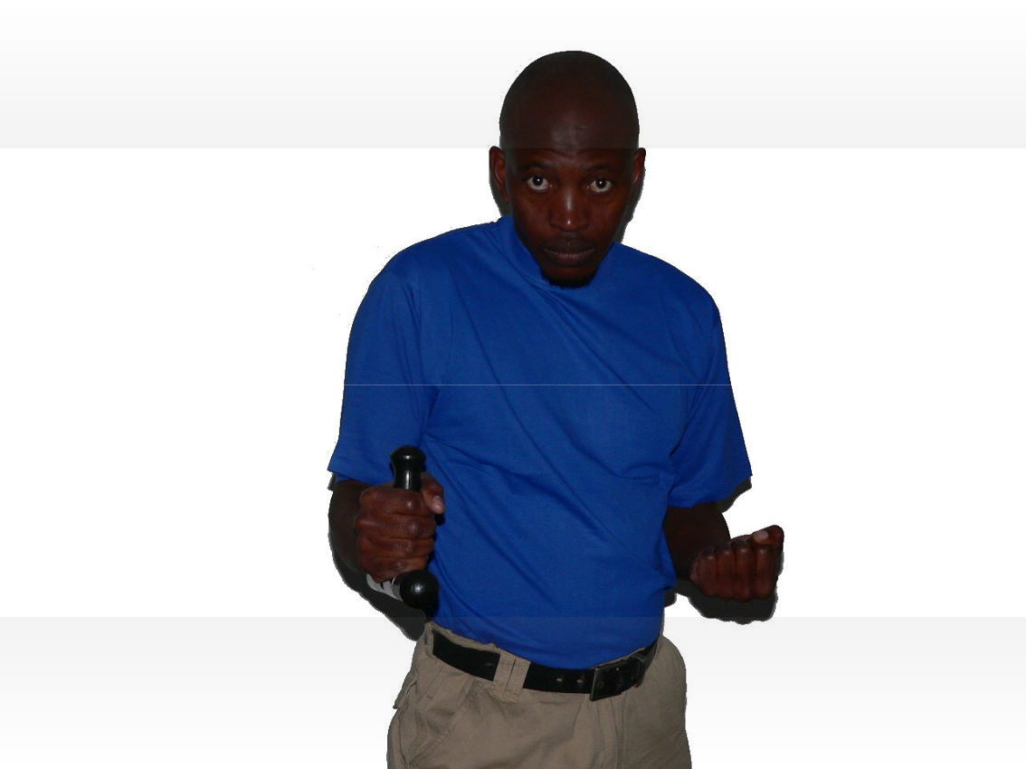  Take pics of the learner
Inner forearm block:
1. | Swing his/her arm across the front of his/her body using an outside in motion.
Outer forearm block:
1. | Swing his/her arm out and across his/her body using and inside out motion. |  |  | 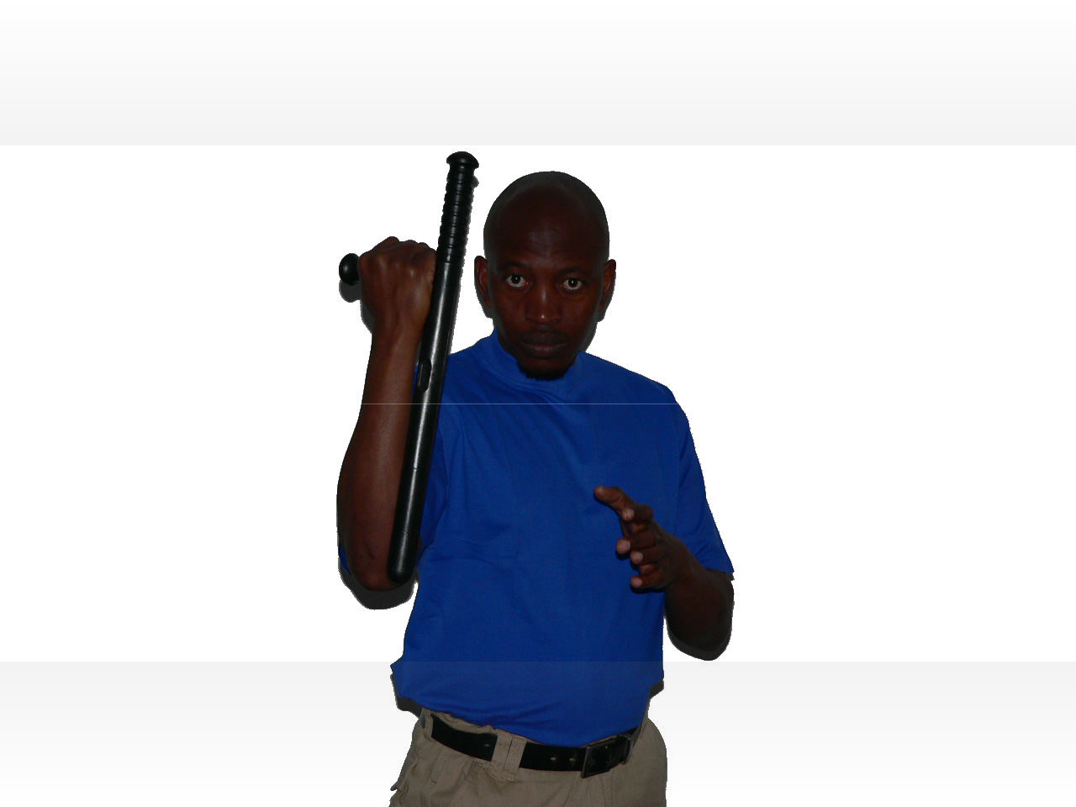  Take pics of the learner
Cross block:
1. | Swing both batons out in front of him/her and form a cross shape to block and temporarily trap the incoming strike. |  |  | 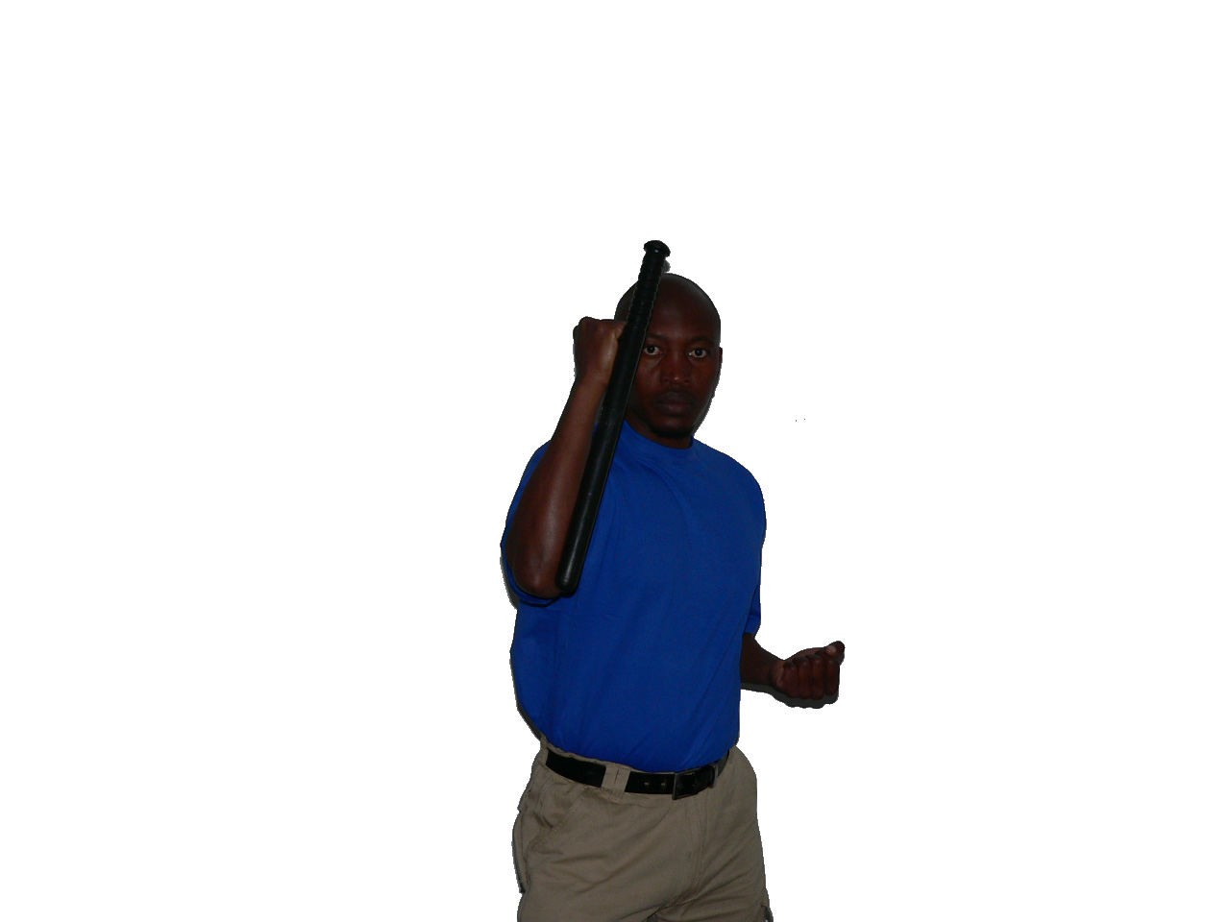  Take pics of the learner
Requirements met

Comments in support of decision
_______________________________________________________________________
_______________________________________________________________________
_______________________________________________________________________
_______________________________________________________________________
_______________________________________________________________________

LEARNER ACTIVITY 4

Demonstrate defensive maneuvers with the straight baton
High block |  | Yes | No | Comments
Did the learner:
1. | Using the two-handed carry position |  |  | 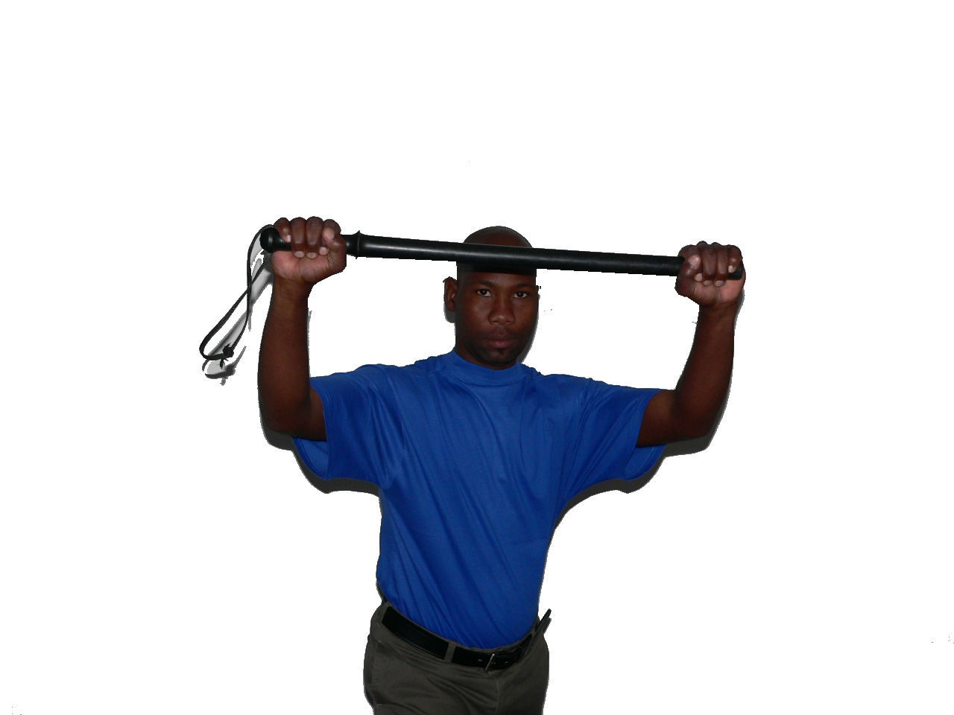  Take pics of the learner
2. | Raise the baton up in front of the body until the long portion is above and in front of the forehead.
3. | Position the support hand, with fingers open, behind the long portion of the baton as the object is blocked
Middle block
1. | Using the two-handed carry position |  |  | 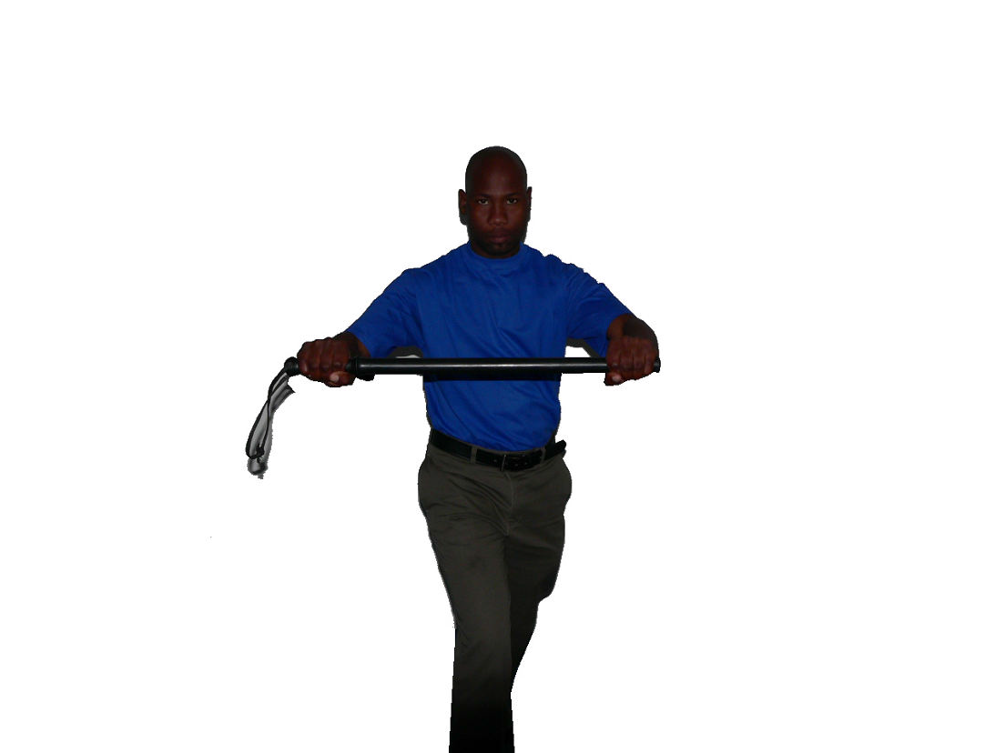  Take pics of the learner
2. | Move the baton to the middle of hiss/her body at a 45-degree angle.
3. | Keep the long portion pointing up and slightly forward of the grip portion that is pointing down.
4. | Position the support hand, with fingers open, behind the long portion of the baton as the object is blocked.
Low block
1. | Swing his/her arm across the front of his/her body using an outside in motion. |  |  | Take pics of the learner
2. | Move the baton to the middle of hiss/her body at a 45-degree angle. |  |  | Take pics of the learner
3. | Move the baton horizontally down in front of the body to just below your groin. |  |  | Take pics of the learner
4. | Position the support hand, with fingers open, behind the long portion of the baton as the object is blocked. |  |  | Take pics of the learner

Strong-side block. |  | Yes | No | Comments
Did the learner:
1. | Using the two-handed carry position |  |  | 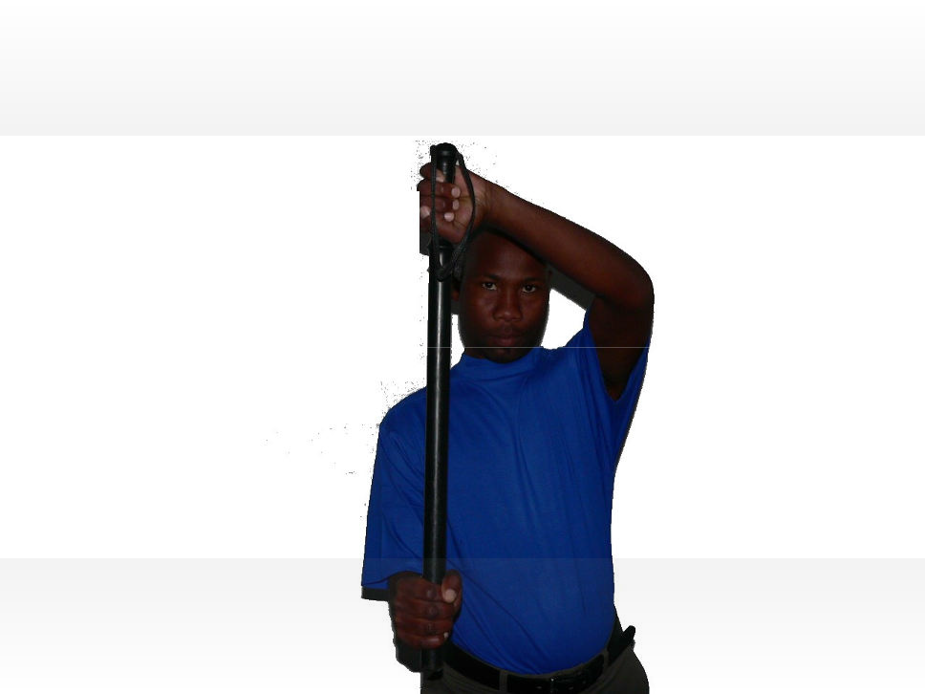  Take pics of the learner
2. | Move the baton vertically toward the strong side
3. | Position the support hand, with fingers open, behind the long portion of the baton as the object is blocked
Forward strike
1. | Using a one-hand carry position |  |  |   Take pics of the learner
2. | Quickly move the baton across the body from his/her strong side to the support side.
3. | Keep the palm facing up as he/she deliver the counter-strike technique horizontally or downward diagonally.
Reverse strike
1. | Using a one-hand carry position |  |  |   Take pics of the learner
2. | Quickly move the baton across the body from his/her strong side to the support side.
3. | Keep the palm facing down as he/ she deliver the counter-strike t technique horizontally or downward diagonally.
Front jab
1. | Using a one-hand carry position |  |  | 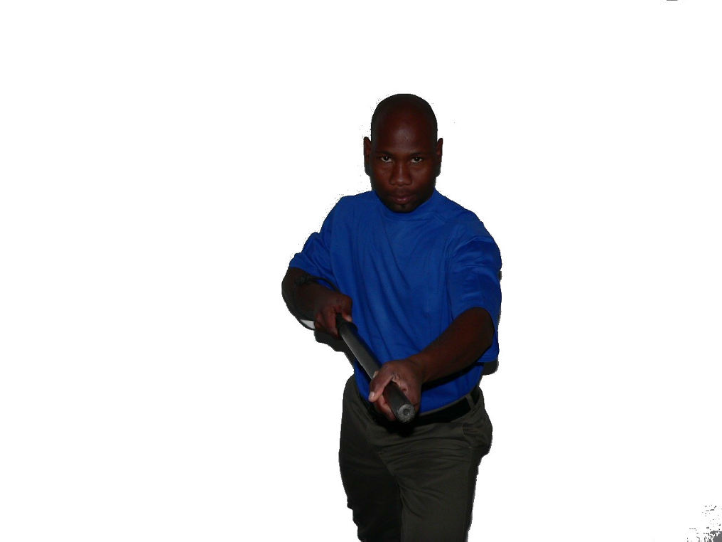  Take pics of the learner
2. | Thrust the long end of his/her baton forward using both the strong and support hands.
3. | Thrust the baton forward horizontally and slightly downward
Rear jab.
1. | Using a one-hand carry position |  |  | 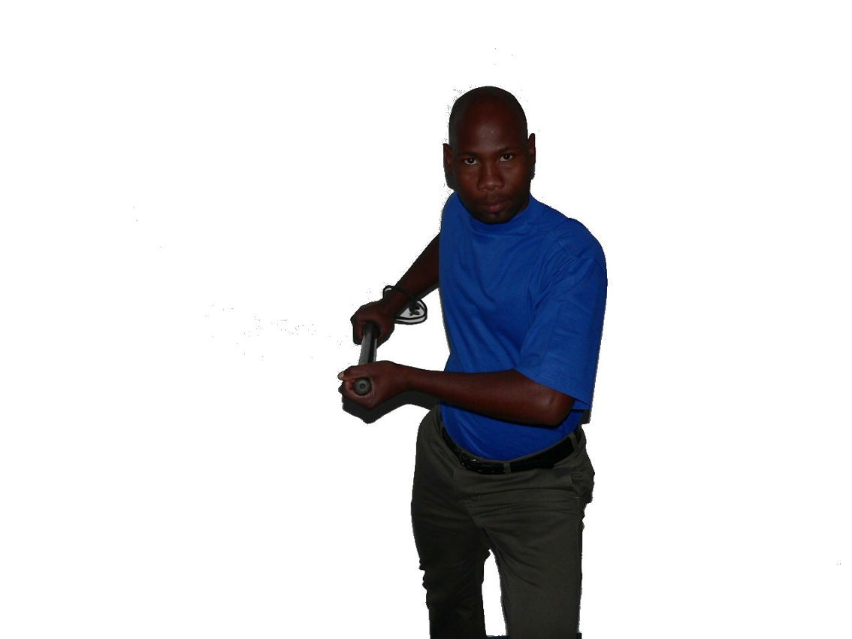  Take pics of the learner
2. | Thrust the long end of his/her baton to the rear using both the strong and support hands.
3. | Thrust the baton rearwards horizontally and slightly downward
Strong-side horizontal strike. |  | Yes | No | Comments
Did the learner:
1. | Using the two-handed carry position to rotate your baton horizontally. |  |  | 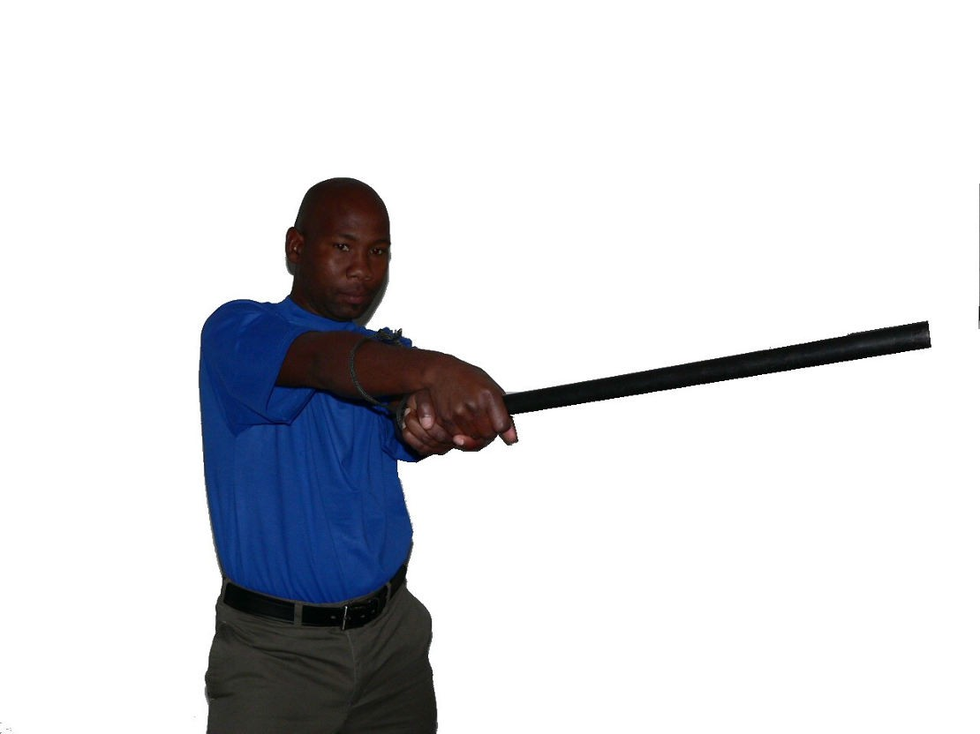  Take pics of the learner
2. | Pull back with the support hand as he/she with their strong hand drives the grip portion or the grip end forward toward the target.
3. | Thrust the grip end or grip portion horizontally, while using both the hands and the strong-side hip to generate power.
Support-side horizontal strike.
1. | Using the two-handed carry position to rotate your baton horizontally. |  |  | 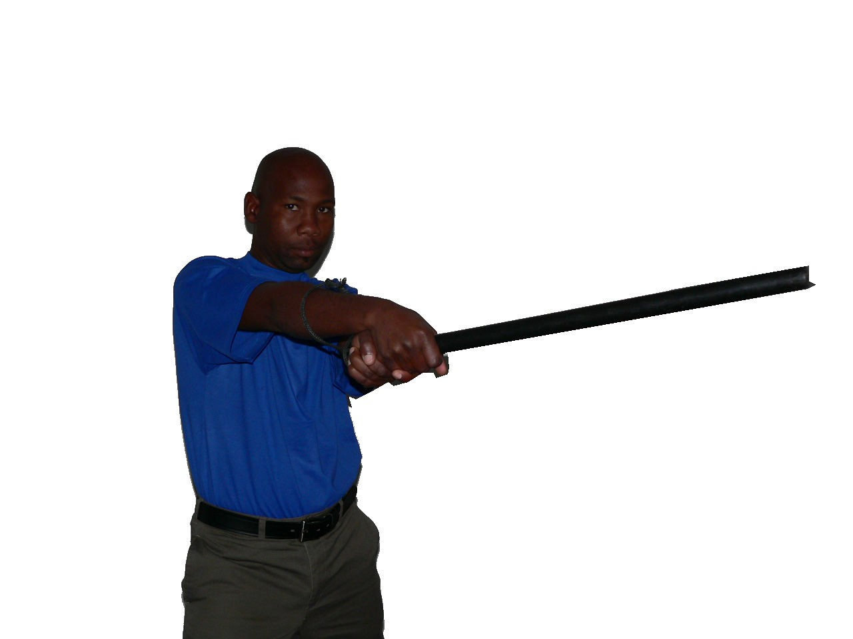  Take pics of the learner
2. | Pull back with the strong hand as he/she with their support hand drives the grip portion or the grip end forward toward the target.
3. | Thrust the long end or long portion horizontally, while using both the hands and the strong-side hip to generate power.
Middle strike.
1. | Using the two-handed carry position to sharply thrust the long portion of the baton forward horizontally. |  |  | 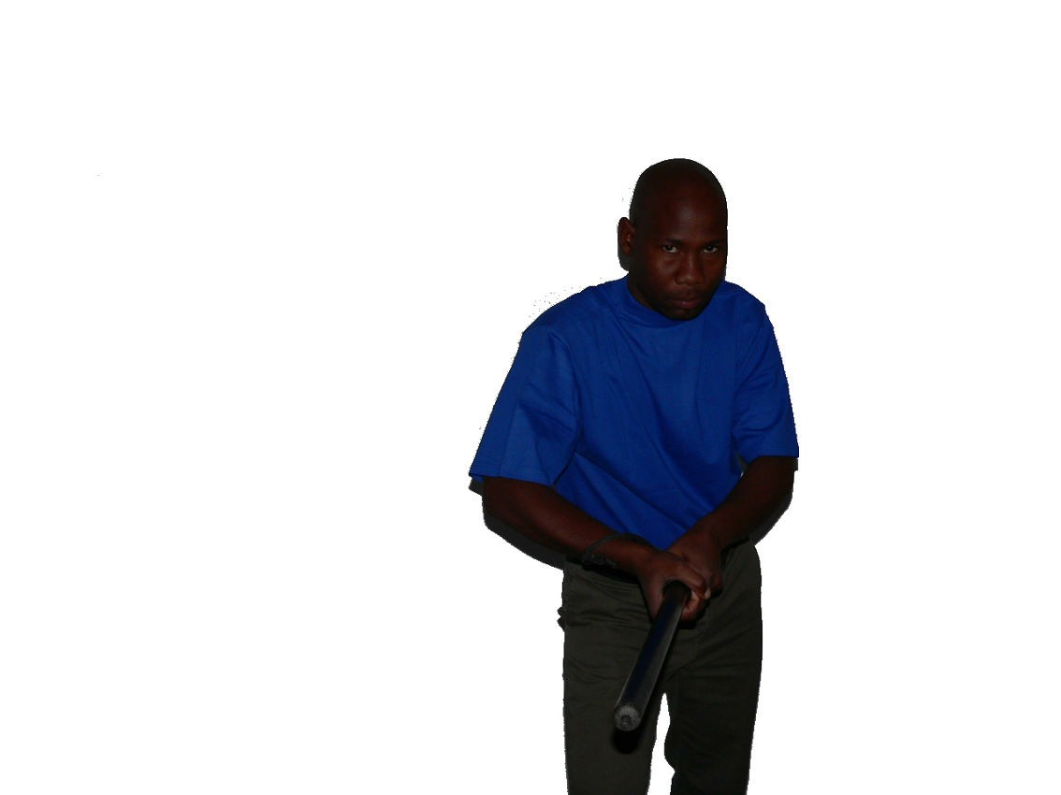  Take pics of the learner
2. | Extend both of arms at the conclusion of the forward thrust.
3. | Use the entire body to generate power.
Requirements met
Comments in support of decision
_______________________________________________________________________
_______________________________________________________________________

LEARNER ACTIVITY 5 (page 24)

Explain in your own the safety guidelines in the use of batons and Tonfa's.
- Do not swing your baton around. Chances are that you might hit an innocent bystander.

- Make sure to carry your baton in such a manner that it cannot be taken from you and used against you.

- Exercise care when entering and existing vehicles as the baton might damage other equipment inside the vehicle.

- Do not hit hard surfaces with the baton as this might cause the baton to break and the pieces might hurt yourself or bystanders. The impact created when hitting a hard surface might cause injury to your arm, hand and wrist.
Requirements achieved | YES |  | NO
Comments in support of decision
_______________________________________________________________________
_______________________________________________________________________
_______________________________________________________________________
_______________________________________________________________________
_______________________________________________________________________
_______________________________________________________________________
_______________________________________________________________________ SELF-ASSESSMENT

The learner must make use of the following self-evaluation checklist to rate himself against the learning outcomes of this particular training module in establishing the level of mastery of the information.

- Not able to comply

- Reasonable compliance (Not acceptable for final evaluation)

- Able to comply fully
 | LEARNING OUTCOMES | 1 | 2 | 3
1 | Describe 2 types of batons.
2 | Demonstrate the common grips for 2 kinds of batons.
3 | Discuss safety guidelines for batons.
4 | Demonstrate defensive maneuver skills when using a baton/tonfa
5 | Demonstrate skills in baton retention.
6 | Explain the legal guidelines for the use of batons.
7 | Demonstrate the correct carry method when carrying a baton.

_Assessor signature_____________________ |  | ________________________
Evidence Collector Signature |  | Date
Learner signature _______________________ |  | ________________________
Security Officer Signature |  | Date

LEARNING UNIT 2

Constraint Apparatus
♦ Describe 2 types of handcuffs.
♦ Describe the purpose of handcuffs.
♦ Demonstrate skills and knowledge for the correct use of handcuffs ♦ Discuss the legal guidelines that apply when using handcuffs.
♦ Describe the safety aspects for the use of handcuffs.

LEARNER ACTIVITY 1 (page 29)

Explain in your own words what is a handcuff. Motivate your answer by providing examples of two distinct subtypes of contemporary metal handcuffs.
They comprise two halves, linked together by a chain or hinge. Each half has a rotating part which engages with a ratchet which is closed around a person's wrist. Without the key, the person cannot move their wrists more than a few centimeters (inches) apart, making many tasks difficult or impossible. This is usually done to prevent suspected criminals from escaping police custody.

There are two distinct subtypes of contemporary metal handcuffs:

- one in which the cuffs are held together by a short chain,
- and another, of more recent origin, which uses a hinge for this purpose.
Requirements achieved | YES |  | NO
Comments in support of decision
_______________________________________________________________________
_______________________________________________________________________
_______________________________________________________________________
_______________________________________________________________________
_______________________________________________________________________
_______________________________________________________________________
_______________________________________________________________________

LEARNER ACTIVITY 2 (page 29)

Explain in your own words why a security officer needs to use handcuffs for.
Handcuffs are restraint devices designed to secure an individual's wrists close together.
Requirements achieved | YES |  | NO
Comments in support of decision
_______________________________________________________________________
_______________________________________________________________________
_______________________________________________________________________
_______________________________________________________________________
_______________________________________________________________________
_______________________________________________________________________
_______________________________________________________________________

LEARNER ACTIVITY 3

Demonstrate the correct use of handcuffs by handcuffing a person.

The assessor will provide a role player for the purposes of the role play.
Compliant suspect |  | Yes | No | Comments
Did the learner:
1. | Tell the suspect to turn and face away from him, spread his feet apart until he tell him to stop, and point his toes out. (The suspect's feet should be more than shoulder width apart.) |  |  | The learners must demonstrate and the facilitator must take photos of each and every learner
2. | Tell the suspect to lock his elbows and move both arms back along his side until both arms are fully extended behind him, keeping his elbows locked.
3. | Tell the suspect to turn both hands until his palms are turned outward, with his thumbs pointing up, and bend forward at the waist until told to stop. The suspect should be bent at the waist at least a 45-degree angle.
4. | Tell the suspect not to move
5. | Shuffle up to the suspect, staying out of arms reach, and tap one of the suspect's hands. At the same time, move back and be ready to respond to resistance by the suspect.
6. | Take out your handcuffs using your strong hand, and position them in a proper carry position.
7. | Approach the suspect carefully, from the outside, at a 45-degree angle.
Compliant suspect |  | Yes | No | Comments
Did the learner:
8. | Use the support hand to grasp the back side of the suspect's hand at the knuckles where fingers meet. |  |  | Learner found competent
9. | Pull the suspect's hand back away from his body. Position the center of the single strand of the bottom handcuff on the suspect's handcuffing notch at the base of his thumb, and push the handcuff on using one smooth motion. |  |  | Learner performed correctly
10. | Ensure that the cuff is snug, then instantly release the reverse handshake grip and move the support hand to grip the suspect's second hand in a handshake grip at the knuckles where the fingers meet the hand. |  |  | Learner correctly performed
11. | Grip the suspect's second hand, then instantly position the top cuff over the suspect's handcuffing notch at the base of the thumb and push the cuff on with one smooth motion. |  |  | Learner found competent
Requirements met

Comments in support of decision
_______________________________________________________________________
_______________________________________________________________________
_______________________________________________________________________
_______________________________________________________________________
_______________________________________________________________________

LEARNER ACTIVITY 4 (page 35)

Explain in your own the safety guidelines when using handcuffs.
- Handcuffs (especially the type used by security officers) have one shortfall: the keys are interchangeable. This means that if the arrested person has handcuffs keys, he can easily free himself and escape.

- A suspect’s hands should always be cuffed behind his back making use of the double lock function of the cuffs. The double lock function requires more than one action with the key before the ratchet will be released.

- Never handcuff a suspect to your person. As you have seen in the movies it is possible for him to overpower you, injure you and escape.

- If you carry a firearm, make sure that it is out of reach of the suspect at all times, especially while placing or removing the cuffs.

- They are called handcuffs for a reason - do not use them as leg or ankle cuffs, and don’t ever handcuff a hand to an ankle!

- Never handcuff two or more suspects to each other. This creates a security risk as well as a risk of injury to the suspects.
Requirements achieved | YES |  | NO
Comments in support of decision
_______________________________________________________________________
_______________________________________________________________________
_______________________________________________________________________
_______________________________________________________________________
_______________________________________________________________________
_______________________________________________________________________
_______________________________________________________________________

SELF-ASSESSMENT

The learner must make use of the following self-evaluation checklist to rate himself against the learning outcomes of this particular training module in establishing the level of mastery of the information.

- Not able to comply

- Reasonable compliance (Not acceptable for final evaluation)

- Able to comply fully
 | LEARNING OUTCOMES | 1 | 2 | 3
1 | Describe 2 types of handcuffs.
2 | Describe the purpose of handcuffs.
3 | Demonstrate skills and knowledge for the correct use of handcuffs
4 | Discuss the legal guidelines that apply when using handcuffs.
5 | Describe the safety aspects for the use of handcuffs.

_Assessor signature_____________________ |  | ________________________
Evidence Collector Signature |  | Date
Learner signature _______________________ |  | ________________________
Security Officer Signature |  | Date

LEARNING UNIT 3

Defensive Sprays
- Discuss the purpose of defense sprays.
- Explain the effects of defensive sprays.
- Demonstrate skills and knowledge in the correct use of defensive sprays.
- Explain the various spray patterns of defensive sprays.
- Describe the safety aspects for the use of defense sprays.

LEARNER ACTIVITY 1 (page 39)

Define defensive spray.
Pepper spray (also known as OC spray (from "Oleoresin Capsicum"), OC gas, capsicum spray, or oleoresin capsicum) is a lachrymatory agent (a chemical compound that irritates the eyes to cause tears, pain, and even temporary blindness) that is used in riot control, crowd control, and personal self-defense, including defense against dogs and bears.
Requirements achieved | YES |  | NO
Comments in support of decision
_______________________________________________________________________
_______________________________________________________________________
_______________________________________________________________________
_______________________________________________________________________
_______________________________________________________________________
_______________________________________________________________________
_______________________________________________________________________

LEARNER ACTIVITY 2 (page 39)

List the effects that defensive spray will have when it is used against a suspect.
To achieve the desired effects, a defense spray must be aimed towards the face of the aggressor. The general effects of most defense sprays are

- Disorientation
- eyes slamming shut
- restricted breathing
- uncontrollable coughing
- Blindness
- and intense burning sensation.
Requirements achieved | YES |  |  | NO
Comments in support of decision
_______________________________________________________________________
_______________________________________________________________________
_______________________________________________________________________
_______________________________________________________________________
_______________________________________________________________________
_______________________________________________________________________
_______________________________________________________________________

LEARNER ACTIVITY 3

Demonstrate the correct use of defensive spray.

The assessor will provide the defensive spray.
Compliant suspect |  | Yes | No | Comments
Did the learner:
1. | Remove and the safety cap
2. | Aimed at the eyes.
3. | Spray and run
Requirements met

Comments in support of decision
_______________________________________________________________________
_______________________________________________________________________
_______________________________________________________________________
_______________________________________________________________________
_______________________________________________________________________

LEARNER ACTIVITY 4 (page 43)

List the three basic types of spray patterns. Complete the missing words in the columns provided.
Advantages | Dis-advantages
Distributes large amounts of spray into vast area, helpful for riot conditions, crowd control, raids, and correctional use | 8.Potential for increased exposure to surrounding area, to innocent bystanders and to the sprayer

4.1 Ballistic Stream
Advantages | Dis-advantages
1.Reduces likelihood of contaminating other subjects in the immediate area. | Requires accurate aim to hit target.
Potential for inhalation by sprayer reduced. | 2.Only affects area struck by stream.
3.Less likely to be affected by wind or to be blown back in your Face | Potential for irritation of target's respiratory system reduced.
Longer range. | 4.Takes longer to create irritation than a mist spray.

4.2 Full Cone Mist Spray
Advantages | Dis-advantages
Requires less accuracy | 5.Potential for increased exposure to surrounding area, to innocent bystanders and to the sprayer
6. Covers a wider area, so more likely to hit target | Strong winds can diminish effectiveness
Potential for inhalation increased, enhancing effectiveness on target | 7.Potential for inhalation increased, Enhancing effectiveness on innocent bystanders and sprayer

4.3 Magnum Fogger
Requirements achieved | YES |  | NO
Comments in support of decision
_______________________________________________________________________
_______________________________________________________________________
_______________________________________________________________________
_______________________________________________________________________
_______________________________________________________________________
_______________________________________________________________________
_______________________________________________________________________

SELF-ASSESSMENT

The learner must make use of the following self-evaluation checklist to rate himself against the learning outcomes of this particular training module in establishing the level of mastery of the information.

- Not able to comply

- Reasonable compliance (Not acceptable for final evaluation)

- Able to comply fully
 | LEARNING OUTCOMES | 1 | 2 | 3
1 | Discuss the purpose of defense sprays.
2 | Explain the effects of defensive sprays.
3 | Demonstrate skills and knowledge in the correct use of defensive sprays.
4 | Explain the various spray patterns of defensive sprays.
5 | Describe the safety aspects for the use of defense sprays.

LEARNING UNIT 4

Two Way Radio Communication
♦ Identify the components of a two way radio.
♦ Explain the operating procedures for a two way radio.
♦ Explain the principles of voice procedure.
♦ Use the phonetic alphabet during a radio transmission.
♦ Use common radio terminology during a radio transmission.
♦ Demonstrate the correct radio procedures during single and multiple radio calls.
♦ Demonstrate the correct radio procedures during a all station call.
♦ Demonstrate the correct radio procedures for emergency radio calls.
♦ Demonstrate the correct radio procedures when relaying messages.
♦ Explain the principles of radio procedures.

LEARNER ACTIVITY 1 (page 50)

List the operating rules when using a radio.
- Listen out before speaking to ensure that the frequency is clear and do not cut in on other transmissions. Allowance must be made for transmission where you can hear only one of the participants in a conversation.

- Observe short pauses between phrases and at the end of a conversation to allow for break-in-working. The press-to-talk (PTT) switch or the voice-operated switch (VOX) must be released when pausing.

- Answer all calls immediately and in the correct sequence.

- Ensure that the radio set returns to receive after each transmission. A jammed PTT switch will reduce a good net to a state of chaos.

- To utilise circuit time more efficiently, all messages or their substance must be written down prior to transmission. Those messages which must be delivered by the receiving operator to another person or which are preceded by the pro-word “MESSAGE” must be written down.

- Transmission via radio should be clear with a natural emphasis on each word and should be spoken in natural phrases, not word by word.

- if this procedure is followed, no complaints can result

- When it is necessary for a station to initiate test signals, either for the adjustment of a transmitter, before making a call, or for the adjustment of a receiver, such signals will not continue for longer that 10 seconds, and will consist of spoken numerals (1,2,3, etc) followed by the call sign of the transmitting station.

- The station that begins the transmission must also terminate it. ___________________________________________________________________
_______________________________________________________________________
_______________________________________________________________________
_______________________________________________________________________
_______________________________________________________________________
_______________________________________________________________________
_______________________________________________________________________
_______________________________________________________________________
_______________________________________________________________________
_______________________________________________________________________
Requirements achieved | YES |  | NO
Comments in support of decision
_______________________________________________________________________
_______________________________________________________________________
_______________________________________________________________________
_______________________________________________________________________
_______________________________________________________________________
_______________________________________________________________________
_______________________________________________________________________

LEARNER ACTIVITY 2 (page 51)

Explain the meaning of "BASS" mean.
♦ | Brief: message must be brief and only contain important facts.
♦ | Accurate: details given must be clear and accurate.
♦ | Security: never transmit classified information unless it is disguised in some way.
♦ | Speed: do not rush the message but be brief and co |  | be brief and concise.
 | Requirements achieved | YES |  | NO
Comments in support of decision
_______________________________________________________________________
_______________________________________________________________________
_______________________________________________________________________
_______________________________________________________________________
_______________________________________________________________________
_______________________________________________________________________
_______________________________________________________________________

LEARNER ACTIVITY 3 (page 51)

Explain the meaning of "RSVP" mean.
♦ | Rhythm: use short phrases with pauses.
♦ | Speed: remember the receiver may wish to write down the message.
♦ | Volume: do not shout but speak slightly louder than normal.
♦ | Pitch: pitch the voice slightly higher than normal.
 | Requirements achieved | YES |  | NO
Comments in support of decision
_______________________________________________________________________
_______________________________________________________________________
_______________________________________________________________________
_______________________________________________________________________
_______________________________________________________________________
_______________________________________________________________________
_______________________________________________________________________

LEARNER ACTIVITY 4

This is a role play exercise:

Ask a co-learner to help you practice the phonetic alphabet.

Write down the following sentence on a piece of paper and keep it with you:

THE QUICK BROWN FOX JUMPS OVER THE LAZY DOG’S BACK

Practice spelling the sentence (that contains all the letters of the alphabet) using the phonetic alphabet.

 |  | Yes | No | Comments
Did the learner spell the following correct.
1. | Tango
2. | Hotel
3. | Echo
4. | Quebec
5. | Uniform
6. | India
7. | Charlie
8. | Kilo
9. | Bravo
10. | Romeo
11. | Oscar
12. | Whiskey
13. | November
14. | Foxtrot
15. | Oscar
16. | X-ray

 |  | Yes | No | Comments
Did the learner spell the following correct.
17. | Juliet
18. | Uniform
19. | Mike
20. | Papa
21. | Sierra
22. | October
23. | Victor
24. | Echo
25. | Romeo
26. | Tango
27. | Hotel
28. | Echo
29. | Lima
30. | Alpha
31. | Zulu
32. | Yankee
33. | Delta
34. | October
35. | Golf
36. | Sierra
37. | Bravo
38. | Alpha
39. | Charlie
40. | Kilo
_______________________________________________________________________
_______________________________________________________________________
_______________________________________________________________________
Requirements achieved | YES |  | NO
Comments in support of decision
_______________________________________________________________________
_______________________________________________________________________
_______________________________________________________________________
_______________________________________________________________________

LEARNER ACTIVITY 5

Role play:

You are stationed at a remote (far away) site, where the radio reception is not very good. You are on duty alone, and notice that there are about two hundred people marching towards the gate with placards. It seems as if they may be on strike and are going to force their way on to the premises.

Practice “sending” a radio call explaining the details and requesting assistance.

You will have to get another radio operator to relay your message, as “Control” cannot hear you properly.

Change places with your co-learner. You are now “Control”, and the co -learner is sending the message.

Send a multiple call for backup.

Remember to spell out the address using the phonetic alphabet. Your transmission can include made-up codes for certain situations. Your call should include the items on the checklist below.
 |  |  | Yes |  | No | Comments
Did the learner:
1. | Use his call sign to identify himself
2. | Say “Over” at the end of a sentence
3. | Say “Out” at the end of a transmission
4. | Say “Roger “ when confirming something
5. | Send a “Sitrep” – a situation report
6. | Begin his transmission with PAN-PAN
7. | Begin his transmission with  MAYDAY
8. | Tell the receiving station its signal strength
 |  |  | Yes |  | No | Comments
Did the learner:
9. | Ask the receiving station to “Say  again” when something was not clear
10. | Say “Standing by” while waiting for a reply
11. | Say “Over and out” at any time
12. | Ask the receiving station to “Relay to” during bad reception
Requirements achieved |  | YES |  |  |  |  | NO
Comments in support of decision
_______________________________________________________________________
_______________________________________________________________________
_______________________________________________________________________
_______________________________________________________________________
_______________________________________________________________________
_______________________________________________________________________
_______________________________________________________________________

LEARNER ACTIVITY 6 (page 57)

List five principles of radio procedures
- Do not use abusive language over the air. Apart from prejudicing voice procedure, this can result, in licenses being revoked.
- Do not play music in the background.
- Do keep the radio room secure.
- Do treat radios as technical equipment and handle them with care to prevent damage.
- Do use radios for the transmission of official messages only; the transmission of music or other entertainment is prohibited.
- Always use the correct call sign.
- Ensure that the battery is always fully charged.
- Always carry out a radio test before going on duty.
- Keep messages short, concise and to the point.
- Prepare all messages mentally before transmitting them.
Requirements achieved | YES |  | NO
Comments in support of decision
_______________________________________________________________________
_______________________________________________________________________
_______________________________________________________________________
_______________________________________________________________________
_______________________________________________________________________
_______________________________________________________________________

SELF-ASSESSMENT

The learner must make use of the following self-evaluation checklist to rate himself against the learning outcomes of this particular training module in establishing the level of mastery of the information.

- Not able to comply
- Reasonable compliance (Not acceptable for final evaluation)
- Able to comply fully
 | LEARNING OUTCOMES | 1 | 2 | 3
1 | Identify the components of a two way radio.
2 | Explain the operating procedures for a two way radio.
3 | Explain the principles of voice procedure.
4 | Use the phonetic alphabet during a radio transmission.
5 | Use common radio terminology during a radio transmission.
6 | Demonstrate the correct radio procedures during single and multiple radio calls.
7 | Demonstrate the correct radio procedures during a all station call.
8 | Demonstrate the correct radio procedures for emergency radio calls.
9. | Demonstrate the correct radio procedures when relaying messages.
10 | Explain the principles of radio procedures.

_Assessor signature_____________________ |  | ________________________
Evidence Collector Signature |  | Date
Learner signature _______________________ |  | ________________________
Security Officer Signature |  | Date

LEARNING UNIT 5

Metal Detectors
- Discuss the purpose of hand-held metal detectors.
- Demonstrate the correct use of a handheld metal detector.
- Demonstrate skills in the use of a metal detector when a search from the front and back needs to be conducted.
- Discuss the legal guidelines that apply when using hand held metal detectors.
- Explain the function of a walk through metal detector.
- Describe the safety aspects for the use of hand held metal detectors.

LEARNER ACTIVITY 1 (page 64)

Explain the difference between a handheld metal detector and a walkthrough metal detector.
The hand-held metal detector is a battery operated, lightweight device used to sense the presence of objects made of any type of metal. This device is light and portable and can be used with ease at any location on a site.

The walk through metal detector is an electronic operated device which typically are used in a variety of environmental conditions and can be used both indoors and outdoors to sense the presence of objects made of any type of metal.
Requirements achieved | YES |  | NO
Comments in support of decision
_______________________________________________________________________
_______________________________________________________________________
_______________________________________________________________________
_______________________________________________________________________
_______________________________________________________________________
_______________________________________________________________________

LEARNER ACTIVITY 2

Demonstrate the correct use of a handheld metal detector during a search.
 |  | Yes | No | Comments
Did the learner:
1. | Make sure that the hand held metal detector is in working order.
2. | Move the hand held metal detector + 20mm (2cm) from the body or item.
3. | Made sure that the person face the security officer when the search is being done.
4. | Start with the headgear and hair by moving the detector from the left side over the crown of the head to the right side of the head.
5. | Move the detector from the collar and shoulders down the front of the person to the waist on the left side then from the shoulder to the waist down the right side. Repeat at the back.
Requirements met

Comments in support of decision
_______________________________________________________________________
_______________________________________________________________________
_______________________________________________________________________
_______________________________________________________________________
_______________________________________________________________________
LEARNER ACTIVITY 3

Demonstrate how to operate the handheld metal detector by switching it on and ensure that it is working.
 |  | Yes | No | Comments
Did the learner:
1. | Turn on the power switch.
2. | Heard the click sound and checked the green LED is on at the same time.
3. | Ensure that the switch click sound stop, to allow the highly sensitive detection to be performed.
Requirements met

Comments in support of decision
_______________________________________________________________________
_______________________________________________________________________
_______________________________________________________________________
_______________________________________________________________________
_______________________________________________________________________

LEARNER ACTIVITY 4

Demonstrate how to use the handheld metal detector by scanning from behind.
 |  | Yes | No | Comments
Did the learner:
1. | Stand behind person to be searched and instruct the person to assume a position with arms outstretched to their sides, palms out parallel with the floor/ground, legs spread out with feet shoulder width apart.
2. | Place side of wand, regardless of left or right, at the top of their head, maintaining a distance of one to two centimeters from the body
3. | Scan over each side of their head, then sweep from neck down the center of the back to the waist and buttocks, scanning to the sides of their waist and back up to the shoulder (both sides), work your way from top of one shoulder outwards to the extended hand.
4. | Go out past the fingertips and return under the hand, scanning the underside of the arm (pay attention to alerts on watches/jewelry on wrists).
5. | Sweep inwards to the armpit, and continue downwards to the foot. At the foot ensure that you scan across the outmost upper side of the shoe.
6. | Continue the scan around the heel and scan the inside top of the foot, - have them lift their foot up to scan the bottom of their foot, then sweep upwards between the legs to the crotch (Note: for dresses stop at hem or just above the knee and go down the other leg.
 |  | Yes | No | Comments
Did the learner:
7. | Conduct a slower scan around the buttocks and thigh/abdomen area from front and rear
8. | Move the detector at a speed of about 0.5 meter per second.
Requirements met

Comments in support of decision
_______________________________________________________________________
_______________________________________________________________________
_______________________________________________________________________
_______________________________________________________________________
_______________________________________________________________________
LEARNER ACTIVITY 5

Demonstrate how to use the handheld metal detector by scanning from the front.
 |  | Yes | No | Comments
Did the learner:
1. | Step in front of person while their arms are still outstretched, and begin the scan with the wand parallel with their shoulders and begin the scan outwards to the hand, then back to the armpit and down to the waist. .
2. | Ensure that you keep the wand 1”2” for this scan to reduce grounds for harassment complaints
3. | If the coats are on then conduct the same screen as normal from behind, but from the front ask that the coat be opened.
4. | Holding the coat front lapel then insert the wand from the front inside to scan the underside of the jacket from armpit to waist.
5. | For Hats, scan the perimeter of the hat and the bill of the hat.
6. | Move the detector at a speed of about 0.5 meter per second.
Requirements met

Comments in support of decision
_______________________________________________________________________
_______________________________________________________________________
_______________________________________________________________________

LEARNER ACTIVITY 6 (page 68)

Explain the legal consequences when legal guidelines are not followed correctly during the use of a handheld metal detector.
As a security officer you do not have the right to search any person without his or her consent. Using the HHMD is also regarded as a search and you will need the person’s permission to search them.

Should the HHMD show that there is a metal object on the person, you may not remove it yourself. Ask the person to explain the object and to remove it if you believe it is necessary.
Requirements achieved | YES |  | NO
Comments in support of decision
_______________________________________________________________________
_______________________________________________________________________
_______________________________________________________________________
_______________________________________________________________________
_______________________________________________________________________
_______________________________________________________________________
_______________________________________________________________________

LEARNER ACTIVITY 7 (page 68)

Explain the safety guidelines during the use of a handheld metal detector.
• | When using HHMD’s the security officer should always bear the following in mind:
• | Position yourself in such a way that you will be able to defend yourself should the person being searched decide to attack you.
• | Do not use HHMD’s to search people with pacemakers (heart beat assistance items) as the HHMD might interfere with its operation.
• | Do not attempt to open or maintain the HHMD yourself, as there are many safety  risks involved in doing so. Only authorized trained technicians may perform  maintenance tasks.
 | Requirements achieved | YES |  | NO
Comments in support of decision
_______________________________________________________________________
_______________________________________________________________________
_______________________________________________________________________
_______________________________________________________________________
SELF-ASSESSMENT

The learner must make use of the following self-evaluation checklist to rate himself against the learning outcomes of this particular training module in establishing the level of mastery of the information.

- Not able to comply

- Reasonable compliance (Not acceptable for final evaluation)

- Able to comply fully
 | LEARNING OUTCOMES | 1 | 2 | 3
1 | Discuss the purpose of hand-held metal detectors.
2 | Demonstrate the correct use of a handheld metal detector.
3 | Demonstrate skills in the use of a metal detector when a search from the front and back needs to be conducted.
4 | Discuss the legal guidelines that apply when using hand held metal detectors.
5 | Explain the function of a walk through metal detector.
6 | Describe the safety aspects for the use of hand held metal detectors.

_Assessor signature_____________________ |  | ________________________
Evidence Collector Signature |  | Date
Learner signature _______________________ |  | ________________________
Security Officer Signature |  | Date

LEARNING UNIT 6

Body Armor
♦ Explain what body armor is.
♦ Discuss the different types of body armor.
♦ Describe the purpose of body armor.
♦ Explain the benefit of wearing/using body armor.
♦ Discuss the legal guidelines that apply when using body armor.
♦ Describe the safety aspects for the use of body armor.

LEARNER ACTIVITY 1(page 75)

Discuss the two types of body armor. Complete the diagram attached to motivate your understanding of the types of body armor.
Two big groups of body armors can be established:

- the set used by law enforcement officers
- and the sets used by the Army

Among the first group, there are different types of body armor characterized by increasing protection power. The classification is not easy, due to the large number of available ammunition calibers and the variations among similar caliber cartridges.

Type I | Minimum level of protection.
Type IIA | Protects from lower velocity 9 mm and 40 S&W ammunition.
Type II | Protects against high velocity 357 Magnum and higher velocity 9 mm ammunition.
Type IIIA | Protects from high velocity 9 mm and 44 Magnum ammunition. Not recommended in hot or humid climate.
Type III | Protects against 7.62 mm Full Metal Jacketed (FMJ) bullets.
Type IV | Protects against .30 caliber armor piercing (AP) bullets.
Special type | No standard custom made, it is be based in any of the standards with addition for special requirements.

Requirements achieved | YES |  | NO
Comments in support of decision
_______________________________________________________________________
_______________________________________________________________________
_______________________________________________________________________
_______________________________________________________________________
_______________________________________________________________________
_______________________________________________________________________
_______________________________________________________________________

LEARNER ACTIVITY 2 (page 78)

Why does security officers wear body armor.
First, armor stops weapons or projectiles from reaching a person's body. Second, it diffuses the weapon's energy so that the final impact causes less damage. While it's not effective in every situation, armor can generally help protect people from serious injury or death, especially against the right weaponry.
Requirements achieved | YES |  | NO
Comments in support of decision
_______________________________________________________________________
_______________________________________________________________________
_______________________________________________________________________
_______________________________________________________________________
_______________________________________________________________________
_______________________________________________________________________
_______________________________________________________________________

LEARNER ACTIVITY 3 (page 78)

List two benefits for wearing body armor.
• | Body armor saves lives. According to industry estimates, more than 1,200 officers have been saved from death or serious injury because they were wearing their armor. This figure includes lives saved and serious injury avoided from assaults and accidents as well as from ballistic threats.
• | Body armor offers flexibility to the wearer in a number of ways:
⇒ | It is available in various levels of protection to accommodate the range of ballistic threats facing wearers (including street assaults and the officers’ own weapons and ammunition).
⇒ | It can be worn as a concealable undergarment; incorporated into a uniform shirt, vest, coat, or other type of outer garment; or worn over the uniform and easily recognizable (such as armor worn by special tactical teams).
⇒ | Many models are available in a variety of coverage's, some armor panels cover the front and back of the torso, while others also wrap around the sides.
⇒ | Ballistic panels can be removed from the carrier on some models so the carrier can be thrown into the washing machine. Many different types of carrier materials are available.
 | Requirements achieved | YES |  | NO
Comments in support of decision
_______________________________________________________________________
_______________________________________________________________________
_______________________________________________________________________
_______________________________________________________________________
_______________________________________________________________________
_______________________________________________________________________
_______________________________________________________________________

LEARNER ACTIVITY 4(page 80)

List at least three safety guidelines in the use of body armor .
- Be sure to read the label on your armor. Familiarize yourself with its level of protection. Labels on armor must identify designated levels of protection and warn if the armor does not protect against rifle fire or sharp-edged or pointed instruments.

- Manufacturers may also add additional safety instructions or information to labels.

- Read and retain for future reference any safety literature accompanying your armor.

- Follow care and maintenance instructions to ensure your armor’s intended performance (see “Care and Maintenance”).

- Seek medical attention if you are shot while wearing your armor, even if the bullet does not penetrate. Although armor protects against blunt trauma from nonpenetrating bullets, internal injuries requiring medical attention may still result.

- Replace your armor immediately if it has been impacted by a bullet or damaged in any way. Some manufacturers replace armor free of charge if they are provided with official documentation concerning the incident.

- Make sure your vest’s level of protection corresponds to the types of threats you face on the streets and that your vest protects against your service weapon and ammunition.
Requirements achieved | YES |  | NO
Comments in support of decision
_______________________________________________________________________
_______________________________________________________________________
_______________________________________________________________________
_______________________________________________________________________
SELF-ASSESSMENT

The learner must make use of the following self-evaluation checklist to rate himself against the learning outcomes of this particular training module in establishing the level of mastery of the information.

- Not able to comply

- Reasonable compliance (Not acceptable for final evaluation)

- Able to comply fully
 | LEARNING OUTCOMES | 1 | 2 | 3
1 | Explain what body armor is.
2 | Discuss the different types of body armor.
3 | Describe the purpose of body armor.
4 | Explain the benefit of wearing/using body armor.
5 | Discuss the legal guidelines that apply when using body armor.
6 | Describe the safety aspects for the use of body armor.

_Assessor signature_____________________ |  | ________________________
Evidence Collector Signature |  | Date
Learner signature _______________________ |  | ________________________
Security Officer Signature |  | Date

LEARNING UNIT 7

Flashlights
♦ Demonstrate skills and knowledge for the correct use of a flashlight.
♦ Demonstrate knowledge and skills in changing the battery of the flashlight during take over of shifts.
♦ Demonstrate the correct carry method of a flashlight during a security patrol.
♦ Demonstrate knowledge by explaining the difference between a battery operated flashlight and a re-chargeable flashlight.
♦ Describe the safety aspects applicable to flashlights.

LEARNER ACTIVITY 1

Demonstrate the correct use of a flash light.
 |  | Yes | No | Comments
Did the learner:
1. | Took the flashlight in the non-firing hand.
2. | Grasped it with the pinkie finger near the lens and the thumb near the rear of the light. The index finger will turn the light on and off.
3. | When shinning the light, hold it over the shoulder, up and away from the body.
Requirements met

Comments in support of decision
_______________________________________________________________________
_______________________________________________________________________
_______________________________________________________________________
LEARNER ACTIVITY 2

Demonstrate the correct use way of changing the battery of the flash light. (The assessor needs to take note of the manufactures specification when performing this assessment activity)

Complete the criteria of the manufacturer in the space provided when performing assessment.
 |  | Yes | No | Comments
Did the learner:
Requirements met

Comments in support of decision
_______________________________________________________________________
_______________________________________________________________________
_______________________________________________________________________

LEARNER ACTIVITY 3 (page 87)

Explain and demonstrate the correct carry method of a flash light.
- The officer should take the flashlight in their non-firing hand. It is grasped with the pinkie finger near the lens and the thumb near the rear of the light. The index finger will turn the light on and off.

- When shinning the light, the officer should hold it over the shoulder, up and away from the body. This is in case an offender starts shooting at the source of the light. It reduces the chances of the officer being hit.

- This method of holding the flashlight also provides the officer with a self-defense option. In a worse case scenario, the officer can swing the light down, using the butt of the light as the impact point. This is not a traditional use of force and should only be used in a life or death situation. If the officer employ the light in this manner, they try to strike at the weapon or wrist of the offender.

- Also, a strike to the collarbone will likely break it, incapacitating both arms.

- If at all possible, the officer should avoid using the maglight as an impact weapon due to possible liability and use of force issues.
Requirements achieved | YES |  | NO
Comments in support of decision
_______________________________________________________________________
_______________________________________________________________________
_______________________________________________________________________
_______________________________________________________________________
_______________________________________________________________________
_______________________________________________________________________
_______________________________________________________________________

LEARNER ACTIVITY 4 (page 91)

Explain the mayor difference between a battery-operated and a re-chargeable flash light.
Non-rechargeable flashlights don't use ordinary AA, C, and D size alkaline batteries. They use 123A lithium batteries because of their multiple advantages over alkalines:

♦ longer shelf life (10 years), higher
♦ power density, higher unit voltage (3 volts), lighter
♦ weight, better cold weather performance, and
The rechargeable batteries use time-tested Nickel-Cadmium technology. Coupled with Rapid Smart Chargers you'll get reliable performance and hundreds of charging cycles from your battery.

Requirements achieved | YES |  | NO
Comments in support of decision
_______________________________________________________________________
_______________________________________________________________________
_______________________________________________________________________
_______________________________________________________________________
_______________________________________________________________________
_______________________________________________________________________
_______________________________________________________________________

LEARNER ACTIVITY 5 (page 92)

Explain at least five safety guidelines when using a flashlight.
- Read and follow manufacturers’ recommendations for product use
- DO NOT MIX batteries of different brands
- DO NOT MIX old and new batteries
- DO NOT MIX alkaline with non-alkaline batteries
- DO NOT USE damaged batteries
- Ensure that proper polarity is observed when installing batteries
- PRIOR TO THEIR USE IN FLAMMABLE ATMOSPHERES, inspect approved
battery powered flashlights to ensure that the batteries are in good condition, and that the proper
- batteries are installed correctly.
- DO NOT inspect the flashlight in a hazardous area or near an open flame.
Requirements achieved | YES |  | NO
Comments in support of decision
_______________________________________________________________________
_______________________________________________________________________
_______________________________________________________________________
_______________________________________________________________________
_______________________________________________________________________
_______________________________________________________________________
_______________________________________________________________________

SELF-ASSESSMENT

The learner must make use of the following self-evaluation checklist to rate himself against the learning outcomes of this particular training module in establishing the level of mastery of the information.

- Not able to comply

- Reasonable compliance (Not acceptable for final evaluation)

- Able to comply fully
 | LEARNING OUTCOMES | 1 | 2 | 3
1 | Demonstrate skills and knowledge for the correct use of a flashlight.
2 | Demonstrate knowledge and skills in changing the battery of the flashlight during take over of shifts.
3 | Demonstrate the correct carry method of a flashlight during a security patrol.
4 | Demonstrate knowledge by explaining the difference between a battery operated flashlight and a re-chargeable flashlight.
5 | Describe the safety aspects applicable to flashlights.

_Assessor signature_____________________ |  | ________________________
Evidence Collector Signature |  | Date
Learner signature _______________________ |  | ________________________
Security Officer Signature |  | Date

LEARNING UNIT 8

Keys
♦ Demonstrate knowledge of key control measures by explaining it.
♦ Demonstrate knowledge of non-mechanical locks.
♦ Demonstrate knowledge of the various locking system components.
♦ Demonstrate knowledge by explain and applying the following procedures:

⇒ Procedures for control of locking devices
⇒ Procedure for possession of locking devices
⇒ Procedure for the control of keys

♦ Explain the control of combination to combination locking devices

LEARNER ACTIVITY 1 (page 97)

Explain key control measures that will contribute to the control of keys.
• Use Interchangeable or Removable Core Locks. These will permit frequent and rapid changes without floor or shop labor. Adequate preplanning will assure that sufficient replacement cores in the various control and master groupings are on hand for immediate use. If a locksmith is on staff, as probably there will be because of the volume of lock changes and installation, much of the core preparation can be done in-house after a suitable system start by the manufacturer.

• Do NOT Utilize Single Control or Grand Master Scheme. The obvious
danger is total compromise of the locking system through loss of loss of accountability of a control or grand master key (or code), or a single core containing the control and grand master combinations.

- Multiple Controls and Multiple Masters. The building can readily be divided into functionally different units. For example, the low-rise, mid-rise, and high-rise floors can be regarded as separate locking zone. Each zone can then be set up to its own control and its own master scheme.

- Multiple Key Blanks. In setting up different control and master schemes for major building elements, it is urged that the key blank style (the profile of the key and keyway) be different for each of them so that a blank for use in one element will not enter the keyway in the other elements. This will avoid unauthorized key use and discourage attempts at it. It would also make the lock combination codes used in one sector available for use in another with low risk of compromise inasmuch as the key blanks would not be interchangeable.

- Arrangements With Single Zones. Any of the customary approaches of distinction by floor or occupancy or both will serve. For example, if the mid-rise is a tenant section, then each of the floors could be provided a separate floor master and all floors included in a zone grand master. At the same time, spaces within the tenant zone which were not for tenant use, such as the maintenance spaces, could remain on separate master systems which were building-wide but confined to a special function such as electrical, mechanical, or janitorial.

- Strict Master Key Control. Master keys at the floor level should be issued on an accountable basis and only to senior personnel of single tenant occupants. If several tenants occupy a single floor, none should have a floor master. Floor masters issued on this basis should be changed after changes in occupancy as well as at the other indicated change intervals.

- Grand Master Keys. These should be issued on a daily basis only, and only to the fewest number of persons with demonstrated imperative need. Using multiple grand masters will reduce vulnerability to compromise but obviously not eliminate it. Issuing grand master keys on a “day basis” only, I.e., to be
returned to security custody prior to departure from the structure by the holder, will further limit exposure. Choosing very carefully those issued grand master keys (or even allowed temporary custody of them) will narrow the exposure still further. It must be remembered that an impression can be made of any key, in a variety of ways, in a matter of seconds and that key can be later reproduced. It is for this reason that absolute security in conventional locking systems is unachievable.

There is a myth in general circulation that maintenance managers or central crafts people, like electricians and all around mechanics, must carry grand master keys for an entire structure to be able to perform their tasks. It is sometimes argued that security guards on patrol rounds also require grand master keys for the same reason.

A moment’s analysis will show this to be a fallacy. Work schedules generally are laid out before the mechanic goes to an area. The required floor or several floor master keys could be issued based upon an approved work schedule. A zone grand master could be issued on the same basis if truly essential. It is hard to see, however, how a craftsman would require simultaneous entry capability to every door in the structure at the same time. In any event, appropriate keys to any area can be available on a 24-hour basis from the security (or maintenance) supervisor on duty and can be issued, as needed, to authorized individuals on an accountable basis. Carriage of master and grand master keys as symbols of prestige is to be actively discouraged.

- Control Keys and Combinations. Obviously no one needs either unless a lock core is to be replaced or a new core pinned. The locksmith will have continuing access to both of these items, so the reliability of that person is of critical importance. Control keys should not be carried at any time except specifically when needed to make scheduled core changes.

- Exterior Doors. These should not be included on any other building master or control system because they are constantly exposed to lock decoding efforts by persons outside the structure. As they are mostly on grade or below grade levels, the doors involved will typically be to specialized maintenance spaces or to public access spaces under the security control of the owner or building manager. Exterior doors which are locked against ingress to the building also require intrusion alarm protection, whether or not the lock combinations are regularly changed.

• Lock Quality and Complexity of Combination Schemes. Although maximum
security locks are probably not generally required for high-rise structures with a bal anced system of security controls, the locks chosen should be of very good quality. Interchangeable core locks which use a single tumbler (pin chamber) to set up control combinations should be avoided because of the ease of creating a control key given any operating key and a little ingenuity. __________________________________________________________________
_______________________________________________________________________
_______________________________________________________________________
_______________________________________________________________________
_______________________________________________________________________
_______________________________________________________________________
_______________________________________________________________________
_______________________________________________________________________
_______________________________________________________________________
_______________________________________________________________________
_______________________________________________________________________
_______________________________________________________________________
_______________________________________________________________________
_______________________________________________________________________
_______________________________________________________________________
_______________________________________________________________________
_______________________________________________________________________
_______________________________________________________________________
_______________________________________________________________________
_______________________________________________________________________ _______________________________________________________________________
_______________________________________________________________________
_______________________________________________________________________
_______________________________________________________________________
_______________________________________________________________________
_______________________________________________________________________
_______________________________________________________________________
_______________________________________________________________________
Requirements achieved | YES |  | NO
Comments in support of decision
_______________________________________________________________________
_______________________________________________________________________
_______________________________________________________________________
_______________________________________________________________________
_______________________________________________________________________
_______________________________________________________________________
_______________________________________________________________________

LEARNER ACTIVITY 2 (page 98)

Explain what non mechanical locks refers to.
If the building utilized automated entry at any locations, there will be electro mechanical locks (card readers, digital keyboards, or some combination). If a particular door is equipped only with the electro-mechanical equipment, and not with the conventional building locksets, it will be secure against entry except via the automated entry device. On the other hand, such doors may at some time be converted to other use and be restored to the general building locking program. It is recommended that provision be included in the door for a general building lockset but that an operating core be installed only when needed. This will preserve the ability to modify that door with no skilled floor labor by merely deleting it from the automated system and installing an operating core.
Requirements achieved | YES |  | NO
Comments in support of decision
_______________________________________________________________________
_______________________________________________________________________
_______________________________________________________________________
_______________________________________________________________________
_______________________________________________________________________
_______________________________________________________________________
_______________________________________________________________________

LEARNER ACTIVITY 3 (page 100)

Discuss the basic procedures for:

♦ Control of locking devices.
♦ Possession of locking devices.
♦ Control of keys.

Procedures for control of locking devices

♦ The Security Department/company shall control all locking devices.

⇒ The Security Department shall be responsible for the issuance, installation, repair and recapture of all locking devices.
⇒ The Plant Layout Superintendent shall notify the Security Manager in advance of any building construction, occupancy, or area relocation which would involve the installation, alteration, or repair of locking devices.

Procedure for possession of locking devices

♦ Employees may be issued locking devices, subject to the approval limitations set forth in the SUMMARY OF APPROVALS to this instruction.

Procedure for the control of keys

♦ Possession of Company Keys

⇒ Issuance of Company keys to employees is subject to approval limitations set forth in the SUMMARY OF APPROVALS to this instruction, and requires execution of accountability receipts by employees to whom such keys are issued.

____________________________________________________________________
______________________________________________________________________
______________________________________________________________________
______________________________________________________________________
______________________________________________________________________
______________________________________________________________________
______________________________________________________________________
______________________________________________________________________
______________________________________________________________________
______________________________________________________________________
______________________________________________________________________
______________________________________________________________________
______________________________________________________________________
______________________________________________________________________
______________________________________________________________________
______________________________________________________________________
____________________________________________________________________________________________________________________________________________
______________________________________________________________________
______________________________________________________________________
______________________________________________________________________
______________________________________________________________________
______________________________________________________________________
______________________________________________________________________
______________________________________________________________________
______________________________________________________________________
______________________________________________________________________
______________________________________________________________________
______________________________________________________________________
______________________________________________________________________
______________________________________________________________________
______________________________________________________________________
______________________________________________________________________
_____________________________________________________________________________________________________________________________________________
______________________________________________________________________
______________________________________________________________________
______________________________________________________________________
______________________________________________________________________
Requirements achieved | YES |  | NO
Comments in support of decision
______________________________________________________________________
______________________________________________________________________
______________________________________________________________________
______________________________________________________________________
______________________________________________________________________
______________________________________________________________________
______________________________________________________________________

SELF-ASSESSMENT

The learner must make use of the following self-evaluation checklist to rate himself against the learning outcomes of this particular training module in establishing the level of mastery of the information.

- Not able to comply

- Reasonable compliance (Not acceptable for final evaluation)

- Able to comply fully
 | LEARNING OUTCOMES | 1 | 2 | 3
1 | Demonstrate knowledge of key control measures by explaining it
2 | Demonstrate knowledge of non-mechanical locks
3 | Demonstrate knowledge of the various locking system components
4 | Demonstrate knowledge by explain and applying the following procedures:  ♦ Procedures for control of locking devices  ♦ Procedure for possession of locking devices  ♦ Procedure for the control of keys
5 | Explain the control of combination to combination locking devices

_Assessor signature_____________________ |  | ________________________
Evidence Collector Signature |  | Date
Learner signature _______________________ |  | ________________________
Security Officer Signature |  | Date

LEARNING UNIT 9

MAINTENANCE OF SECURITY EQUIPMENT
♦ Demonstrate knowledge by explaining the importants of good storage methods of all security equipment.
♦ Demonstrate knowledge and skills by explaining maintenance check for all security equipment.
♦ Demonstrate knowledge and skills by explaining the procedure for reporting defective equipment.
♦ Demonstrate knowledge by explaining the purpose of issuing security equipment.

LEARNER ACTIVITY 1

Demonstrate the correct care and maintenance of a flash light during a pre-shift check.
 |  | Yes | No | Comments
Did the learner:
1. | Check the lamp to ensure that it is working.
2. | Check the battery for good working condition and if it is charged.
3. | Check the general condition of the flash light.
Requirements met

Comments in support of decision
_______________________________________________________________________
_______________________________________________________________________
_______________________________________________________________________

LEARNER ACTIVITY 2 (page 112)

Explain in your own words the pre-shift check that needs to be done on handcuffs.
Pre-shift checks

Pouch

- No tears in the canvas material.

- The metal rivets are securely in place with no tears in the material around them.

Handcuffs

- Handcuffs are durable and do not need much maintenance. Check for visible signs of wear and tear, cracks and breakages. Test the ratchet and locking mechanisms daily and oil them lightly from time to time.
- Ensure that the key unlocks the locking mechanism.
- Do not accept faulty equipment when signing on for duty.
Requirements achieved | YES |  | NO
Comments in support of decision
_______________________________________________________________________
_______________________________________________________________________
_______________________________________________________________________
_______________________________________________________________________
_______________________________________________________________________
_______________________________________________________________________
_______________________________________________________________________

LEARNER ACTIVITY 3 (page 107)

Identify at least 5 critical areas of a two way radio that needs to be inspected during a hand over of a shift
♦ | Antenna
♦ | Battery
♦ | On/Off switch
♦ | Volume
♦ | Squelch
♦ | Radio number
♦ | Condition of radio
♦ | Channel
 | Requirements achieved | YES |  | NO
Comments in support of decision
_______________________________________________________________________
_______________________________________________________________________
_______________________________________________________________________
_______________________________________________________________________
_______________________________________________________________________
_______________________________________________________________________
_______________________________________________________________________

LEARNER ACTIVITY 4 (page 113)

Explain the storage procedure for defensive spray.
Do not leave your defense spray in any area that may exceed 125 degrees or drop below -15 degrees. Excessive heat or cold may cause the can to leak or burst.
Requirements achieved | YES |  | NO
Comments in support of decision
_______________________________________________________________________
_______________________________________________________________________
_______________________________________________________________________
_______________________________________________________________________
_______________________________________________________________________
_______________________________________________________________________
_______________________________________________________________________

LEARNER ACTIVITY 5

Demonstrate the care and maintenance of defensive sprays.
 |  | Yes | No | Comments
Did the learner:
1. | Ensure that the safety seal, which indicates whether the trigger has been activated, is still in place.
2. | Make sure that the pouch is not damaged in any way.
3. | Check for visible sign of damage to the canister, trigger and safety seal.
4. | If the seal has been broken, the trigger or pouch damaged or it feels very light, refuse to accept it and request a new canister.
Requirements met

Comments in support of decision
_______________________________________________________________________
_______________________________________________________________________
_______________________________________________________________________
_______________________________________________________________________
_______________________________________________________________________
LEARNER ACTIVITY 6

Demonstrate the care and maintenance of hand held metal detectors.
 |  | Yes | No | Comments
Did the learner:
1. | Check for visible signs of damage to the casing of the HHMD
2. | Change the battery when hearing the low battery signal.
3. | Test the unit on himself or a colleague before going on duty, to make sure that it would sense metal objects.
Requirements met

Comments in support of decision
_______________________________________________________________________
_______________________________________________________________________
_______________________________________________________________________

LEARNER ACTIVITY 7 (page 115)

List at least five factors in the care and maintenance of body armor which is critical in continuous use of it.
- DO follow the manufacturer’s instructions for the care and maintenance of your armor.

- DO hand wash your armor with a mild detergent in cold or warm water, and rinse it thoroughly to remove all traces of detergent.

- DO drip dry the armor indoors.

- DO regularly inspect your armor for cuts, tears, and other damage to the carrier and ballistic elements.

- DO contact the manufacturer with any questions about cleaning the armor.

- DO NOT machine wash or dry your armor; machine laundering can affect the
- ballistic material.

- DO NOT use bleach or products containing bleach in laundering your armor.

- DO NOT use commercial laundries because they may use harsh chemicals that can affect your armor’s protective capabilities.

- DO NOT dry clean your armor because dry cleaning solvents can affect your armor’s protective capabilities.

- DO NOT dry your armor outdoors. Some ballistic fabrics degrade as a result of ultraviolet exposure.

- DO NOT attempt to make repairs to your armor. Armor should be returned to the manufacturer for repairs or replacement.
Requirements achieved | YES |  | NO
Comments in support of decision
_______________________________________________________________________
_______________________________________________________________________
_______________________________________________________________________
LEARNER ACTIVITY 8

Demonstrate the correct care and maintenance of a flash light during a pre-shift check.
 |  | Yes | No | Comments
Did the learner:
1. | Check the lamp to ensure that it is working.
2. | Check the battery for good working condition and if it is charged.
3. | Check the general condition of the flash light.
Requirements met

Comments in support of decision
_______________________________________________________________________
_______________________________________________________________________
_______________________________________________________________________

LEARNER ACTIVITY 9 (page 107)

Explain the implications of not storing security equipment correctly and promptly.
It takes a lot of money to buy the correct equipment for each site. All equipment are usually been placed at the site due to site specifications and therefore your co-workers will also use some of it to complete the job and to protect himself and the property being guarded.

If one shift does not comply with the general rule the shifts to follow will not be able to perform their functions properly.

All equipment needs to be placed in an inventory list and signed by each shift taking over from each other. Failing to inspect the inventory can result in:

♦ Non-compliance of job function
♦ Financial losses
♦ Investigation into theft and or loss.

It is therefore imperative that an complete check on the working condition needs to be done for every shift take over, issuing of the equipment and returning of the equipment.
Requirements achieved | YES |  | NO
Comments in support of decision
_______________________________________________________________________
_______________________________________________________________________
_______________________________________________________________________
_______________________________________________________________________
_______________________________________________________________________
_______________________________________________________________________
_______________________________________________________________________

LEARNER ACTIVITY 10 (page 116)

Explain the methods of storing security equipment.
All equipment needs to be stored in a secure place. This can be done by locking the equipment either into a storage cabinet or inside a store room/safe.

When equipment needs to be booked out, an entry into either a asset register or inside the occurrence book can be made.

The entry should include the working condition of the equipment as well as the following important information:

♦ Date and time of equipment booked out
♦ Name and contact details to whom it was booked out. ♦ The reason for being booked out.
♦ The serial number/asset number
Requirements achieved | YES |  | NO
Comments in support of decision
_______________________________________________________________________
_______________________________________________________________________
_______________________________________________________________________
_______________________________________________________________________
_______________________________________________________________________
_______________________________________________________________________
_______________________________________________________________________

LEARNER ACTIVITY 11 (page 116)

Explain a standard operating procedure for issuing and receiving security equipment.
♦ | Step 1: Security officer on duty who receives information on/or discovers defective equipment must make an entry in the Occurrence Book.
♦ | Step 2: All relevant information shall be recorded in the Occurrence Book.
♦ | Step 3: All defective security equipment as listed in the inventory that are booked out and received again within the security controlled site must be reported immediately to the Security Supervisor and the shift supervisor that takes over.
♦ | Step 4: On shift take over report any defective equipment to the Site manager before the first patrol and or 10: 00 the morning.
♦ | Step 5: Failing in adhering to the procedure may result in an internal investigation and ultimately in disciplinary actions.
 | Requirements achieved | YES |  | NO
Comments in support of decision
_______________________________________________________________________
_______________________________________________________________________
_______________________________________________________________________
_______________________________________________________________________
_______________________________________________________________________
_______________________________________________________________________
_______________________________________________________________________ SELF-ASSESSMENT

The learner must make use of the following self-evaluation checklist to rate himself against the learning outcomes of this particular training module in establishing the level of mastery of the information.

- Not able to comply

- Reasonable compliance (Not acceptable for final evaluation)

- Able to comply fully
 | LEARNING OUTCOMES | 1 | 2 | 3
1 | Demonstrate knowledge by explaining the importants of good storage methods of all security equipment.
2 | Demonstrate knowledge and skills by explaining maintenance check for all security equipment.
3 | Demonstrate knowledge and skills by explaining the procedure for reporting defective equipment.
4 | Demonstrate knowledge by explaining the purpose of issuing security equipment.

  _Assessor signature_____________________ |  | ________________________
  Evidence Collector Signature |  | Date
  Learner signature _______________________ |  | ________________________
  Security Officer Signature |  | Date
  ________________________
  Date
  ________________________
  Date
  _Assessor signature_____________________ |  | ________________________
  Evidence Collector Signature |  | Date
  Learner signature _______________________ |  | ________________________
  Security Officer Signature |  | Date

